No. S262530
IN THE SUPREME COURT
OF THE STATE OF CALIFORNIA
LEGISLATURE OF THE STATE OF CALIFORNIA,
Petitioner,
ALEX PADILLA, IN HIS OFFICIAL CAPACITY AS SECRETARY OF STATE OF THE STATE OF CALIFORNIA,
Respondent.

DECLARATION OF LILBERT ROY ONTAI IN SUPPORT OF RESPONSE BY THE CITIZENS REDISTRICTING
COMMISSION TO EMERGENCY PETITION AND REQUEST FOR RELIEF FILED BY THE STATE OF CALIFORNIA
LEGISLATURE
CRITICAL DATE: JULY 13, 2020

*MARIAN M. JOHNSTON (SBN 61643)
Email: marianmjohnston@comcast.net
6419 Grangers Dairy Drive Sacramento, CA 95831
Telephone: (916) 832-5534
Attorneyfor 2010 California Citizens Redistricting Commission
1385634.v1
I, Lilbert Roy Ontai, declare under penalty of perjury as follow:
- I am a member of the California Citizens Redistricting Commission established in 2010 (Commission) and am now the Vice-Chair of the Commission.
- I have been a Commissioner since 2010 and fully participated in the activities of the Commission in drawing the district boundary lines for the congressional, Senatorial, Assembly, and State Board of Equalization districts, which the Commission completed on August 15, 2011. My term as a Commissioner will conclude on or about July 2, 2020, when the first eight members of the 2020 Commission will be selected.
- In early 2011, prior to the release to the Commission of the Census Data, the Commission conducted substantial work to prepare for the line drawing. The Commission's activities specifically included:
  - analyzing the distribution of California's urban and rural demographics and determining which cities and towns best represented geographic population clusters that the Commission should hold public hearings; hiring staff and selecting mapping consultant; supervising Commission staff to contact local cities, towns, and other venues to secure specific sites, logistics, accommodations, and equipment needed to hold public hearings.
2
- During this same time, the Commission initiated an outreach program to solicit broad public participation in order to guide the Commission in its future map drawing decisions. Strategies were developed to outreach to communities of social and economic interests, including underrepresented communities and communities in urban, rural, mountain, foothill, desert, and coastal areas. A final schedule was created, detailing specific dates for site visits with plans to outreach to local communities and media outlets. In addition, the Commission collaborated with nonprofit organizations urging public participation using social networks, local community organizations, and various public media networks.
- After the Commission received the Census Data, the Commission engaged in extensive work in connection with its line drawing.
These activities included:
  - creating the first draft proposal for district maps based on
Census Data population using the mandated ranked criteria.
  - conducting public hearing started from the city of Redding to the city of San Diego and encouraging maximum public participation in the line drawing process; holding work sessions to review and consider public input and comments in order to clarify, correct, modify, and adjust mapping lines using the ranked criteria as framework;
3
preparing and presenting the second draft proposal maps to the public for input, followed by more public hearings again from northern to southern California; holding final work sessions to review and consider public input to finalize maps; o Approving and certifying the final maps setting district boundary lines for the congressional, Senatorial, Assembly, and State Board ofEqualization districts.
- The public input received by the Commission to enable it to carry out its redistricting duties including receiving public input from 2700 speakers and 22,000 written comments, conducting 34 public hearings throughout the state, and holding 70 Commission meetings to draft, review, receive input on, and finalize district maps.
- All Commission meetings were conducted after public notice of 14 days and were broadcasted live, recorded, and made available to the public to ensure total transparency.
I declare under penalty of perjury that the foregoing is true and correct. I have firsthand knowledge of the same, except as to those matters described on information and belief, and if called upon to do so, I could and would testify competently thereto.
Executed this 8th day of June, 2020, in San Diego, California.
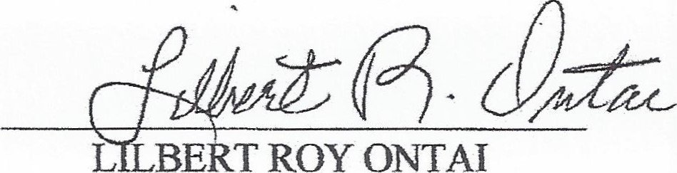
BE
ONTAI

